1.0 Introduction of Shopee
The online shopping platform owned by Sea uses its corporate position to oversee the top e-commerce operation which began serving Singapore in 2015 before extending its reach globally. The largest e Commerce system of Southeast Asia allows both seller support and product exploration across retail corporations and homegrown businesses. Shopee delivers an easy-to-use electronic commerce solution to Southeast Asian markets where it enjoys greatest popularity in Philippines and Singapore and Malaysia alongside additional nations. This platform operates for both individual and business sellers who employ the selling function the same way eBay and Amazon do.[1]

  - Target user of Shopee
Individual customers: Individual customers purchase fashion along with electronics items through Shopee because they find its pricing affordable.
Small and Medium Enterprises (SMEs): The extensive Shopee user base enables Small and Medium Enterprises to reach broader markets through their business expansion.
Large businesses: Shopee Mall finds preference from large businesses because these organizations succeed in online growth through their established status.

  - Key features of Shopee
- Mobile-Friendly Platform :Shopee initiates development of a mobile-friendly platform because the company recognizes the mobile commerce transformation of the marketplace. The smartphone-adaptable platform solution meets the needs of mobile users because its market share continues to increase. [2]
- Shopee Guarantee: Shopee Guarantee allows customers to receive payments they make through the company to sellers after receiving their shipments with confirmation. Shoppers receive this guarantee because they will receive their orders within 10 days after their payment confirmation. [3]
- Global Reach and Cross-Border Selling
Through Shopee enterprises gain access to sell internationally across different marketplaces. Users gain advantages from cross-border selling functions since retailers access various international customers for making their product sales. [2]

- Analyse the User Interface
Layout: Shopee designed its mobile interface with vertical material components displayed along a presentation system. Multiple product categories alongside user-specific recommendations along with promotional banners appear on the homepage to enhance user experience. The visual disorder created by interface design methods prevents users from navigating through the system while overwhelming them with information instead. [4]

Navigation:A bottom bar inside the platform allows users to access Home, Shopee Live, Notifications and Me buttons which lead to user profiles. Users face difficulties when trying to browse between different categories to select their preferred products through this design approach. The application allows people to detect areas that need improvement based on their user feedback. [5]

Color Scheme: Every part of the application utilizes its recognizable orange color palette to boost brand recognition and simplify user identification. The systemwide application of color-based design principles leads to a harmonious perception of visual elements throughout the system. [4]

Typography: Through its choice of easy-to-read fonts, the platform permits users to access all content from any connected device platform. Inconsistent designs combined with multiple small interactive elements in the platform make it harder for users to infer how to navigate and use components according to user reviews. [6]

Shopee's design aligns with several key usability principles:
Consistency and Standards: The design approach of Shopee supports various necessary usability principles.Users experience familiarity on the platform since it uses branded elements alongside its color scheme to maintain visual consistency.
Visibility of System Status: The system status stays visible through Shopee feedback tools such as loading indicators combined with confirmation pop-ups which keeps users informed during all system operations.

- Evaluate the Interface Using Heuristics
- Visibility of System Status
Issue: The Shopee website remains silent about specific error alerts which many users have noted. For an example, Shopee failed to deliver reliable package tracking details to its users during the delivery delays. System feedback clarity helps users avoid frustration because it enables them to complete their tasks without mistakes.
Impact:The slow process of tracking orders causes users to experience both concern and dissatisfaction.Users remain uncertain about their purchase tracking when feedback from the system remains unclear regarding delivery process and payment handling and order verification status.

- Flexibility and Efficiency of Use
Issue:Although loyal customers anticipate improved promotional incentives on the platform Shopee does not provide customized experience benefits to its customers.
Unequal reward distribution could be avoided through multiple loyalty system levels implemented in the platform.
Impact:Regular Shopee users who do not receive equal rewards will lose their motivation to stay loyal to the platform.Users tend to shift their shopping activities from Shopee to Lazada or Amazon due to superior promotions and rewards.

- User Control and Freedom
Issue: Shopee neglects to provide different delivery options to users who subsequently lack the alternative methods to pick their preferred delivery service.[7] For example, Users complain about poor service standards and delivery delays. Users need genuine effective solutions but they cannot find them in the present situation.
Impact:Customers cannot select their delivery companies so they experience dissatisfaction with the shipment times and uncertainties of unreliable carriers.Customers must remain without options to address delivery problems since they lack control over resolution which worsens their irritability.

- Consistency and Standards
Issue: Across the system users encounter multiple design inconsistencies because they encounter different navigation methods and button designs. Shopee adopted the new platform update that turned the site into an e-commerce platform featuring social media interfaces resembling TikTok.
Impact:Users become dissatisfied because the TikTok-like interface of Shopee breaks their expectation of ordinary e-commerce user experience.

- Aesthetic and Minimalist Design
Issue:The homepage features a complicated visual presentation structure because of its excessive information amount. Users face disruptions in their purchasing behavior due to the promotional banners and multiple advertisement types combined in the interface. [8]
Impact:The excessive information on homepage causes customers to lose focus from their primary retail tasks.Users diminish their efficiency due to an extended search time needed to access key shopping categories along with search results.

- Propose UI Improvements
- Improve System Feedback
Proposed Improvement: User satisfaction during system utilization improves when the system receives better navigation controls and extended help feature documentation with tooltips that provide step-by-step guidance. [4]
Justification: The improved system leads to lower frustration alongside less contact with basic inquiries to customer service thus producing superior user satisfaction.

- Rewards and Benefits Overview:
Proposed Improvement: Special rewards section within the user interface displays current-tier exclusive offers and their linked member benefits for viewing purposes. The reward discount structures of Shopee provide equal monetary value under different member levels to customers. [10]
Justification: The rewards program improves usability without removing any membership benefits so more customers stick with the platform.

- Multiple Delivery Options:
Proposed Improvement: Users of Shopee should get multiple delivery options including standard shipping and express shipping and same-day delivery during checkout because Shopee does not show delivery conditions making it harder for customers to make purchase decisions.[11]
Justification:When customers choose their delivery service independently they produce more satisfied shoppers who file less complaints about delivery service.
Ordinary users develop trust in Shopee because they can view the entire delivery options list on the platform.

- Ensure Consistent Navigation Across Devices
Proposed Improvement: A responsive design application enables device navigation consistency because Shopee needs to standardize its user navigation system and create uniform menu structures and navigation methods to build interfaces that are easy and familiar to use. [8]
Justification:Users obtain enhanced speed and better functionality during online shopping due to well-optimized connections between website pages.The use of ironclad navigation logic produces better user satisfaction because users find it easy to reach their objective without encountering additional challenges.

- Reduce Homepage Clutter
Proposed Improvement: The essential homepage update alongside promotion reduction measures brings better user navigation functions while preventing distractions during whitespace optimization. The company should establish an easier homepage layout by eliminating all promotional materials and video components. [9]
Justification: A suitable allocation of space in the layout brings better readability which creates an interface with superior visual attraction.By cleaning user interface mess operators achieve faster outcomes which leads to enhanced engagement data while lowering cart desertion.

- Conclusion
User navigation design within the Shopee shopping platform must be improved to make it easily usable by its customers. The system's enhanced navigation menus alongside improved search functions enable users to achieve higher shopping satisfaction through better understanding of menus and easier bread crumb trails and device-compatible interfaces. service design elements together with user expectations play critical roles in system development where user performance enhancement and positive results are prioritized.

Reference

- Blog Remitly. Everything You Need to Know About Shopee. Retrieved 7 March 2025, from https://blog.remitly.com/finance/shopee/

- Subscribe.Fyi.(13 November 2023).Shopee as an E-commerce Platform: Features and Overview. Retrieved 7 March 2025, from https://subscribed.fyi/blog/shopee-as-an-e-commerce-platform-features-and-overview/

- Raja Idris. (22 January 2019). Four Features Of Shopee That You Didn’t Know. Retrieved 7 March 2025, from https://pokde.net/blog/four-features-of-shopee-that-you-didnt-know

- Farah Seed. (18 September 2028). UI/UX Audit: Shopee vs Lazada. Retrieved 9 March 2025, from https://blog.snappymob.com/ui-ux-audit-shopee-vs-lazada?

- Chua Felicia. (13 June 2021). Shopee: Rethinking The UX Design. Retrieved 9 March 2025, from https://furlisure.medium.com/shopee-rethinking-the-ux-design-9d4082dea1d8

- Budyi Suswanto, Zeinor Rahman. User interface analysis on shopee website using heuiristic method. Retrieved 9 March 2025, from https://techniumscience.com/index.php/technium/article/view/10097?

- LaylaHassan.(September 2022).Investigating Usability Problems on Shopee E-Commerce Website. Retrieved 9 March 2025, from https://www.researchgate.net/publication/367433337_Investigating_Usability_Problems_on_Shopee_E-Commerce_Website?

- UX Pin. (13 August 2024). Design Consistency Guide UI and UX Best Practices. Retrieved 12 March 2025, from https://www.uxpin.com/studio/blog/guide-design-consistency-best-practices-ui-ux-designers/

- Kwok Yan Qi (2021). Shopee Homepage Redesign. Retrieved 12 March 2025, from https://www.kwokyanqi.com/shopee-homepage-redesign?

- Sneha Pillai (7 Jun 2023).“Scaling Customer Loyalty: Designing a Tiered Loyalty Program for the Decathlon App.”. Retrieved 12 March 2025, from https://medium.com/design-bootcamp/scaling-customer-loyalty-designing-a-tiered-loyalty-program-for-the-decathlon-app-5c12e8aa6a68

- Sastra Ananta (4 May 2024). Delivery Options Improvements on Shopee Checkout Page : UI/UX Design Study Case. Retrieved 12 March 2025, from https://sastraananta.medium.com/improvements-shopee-delivery-on-shopee-checkout-page-ui-ux-design-study-case-447b35353c9e

Appendix

Heuristic Evaluation Checklist Based on Jakob Nielsen’s 10 Usability Heuristics: https://sg.docworkspace.com/d/sILTdgcOQAo6fy74G

3a) 3c) A picture about example i put in this 2 points: delivery delay too many times but didn’t get a notification and they are unable to choose the shipping method they want.
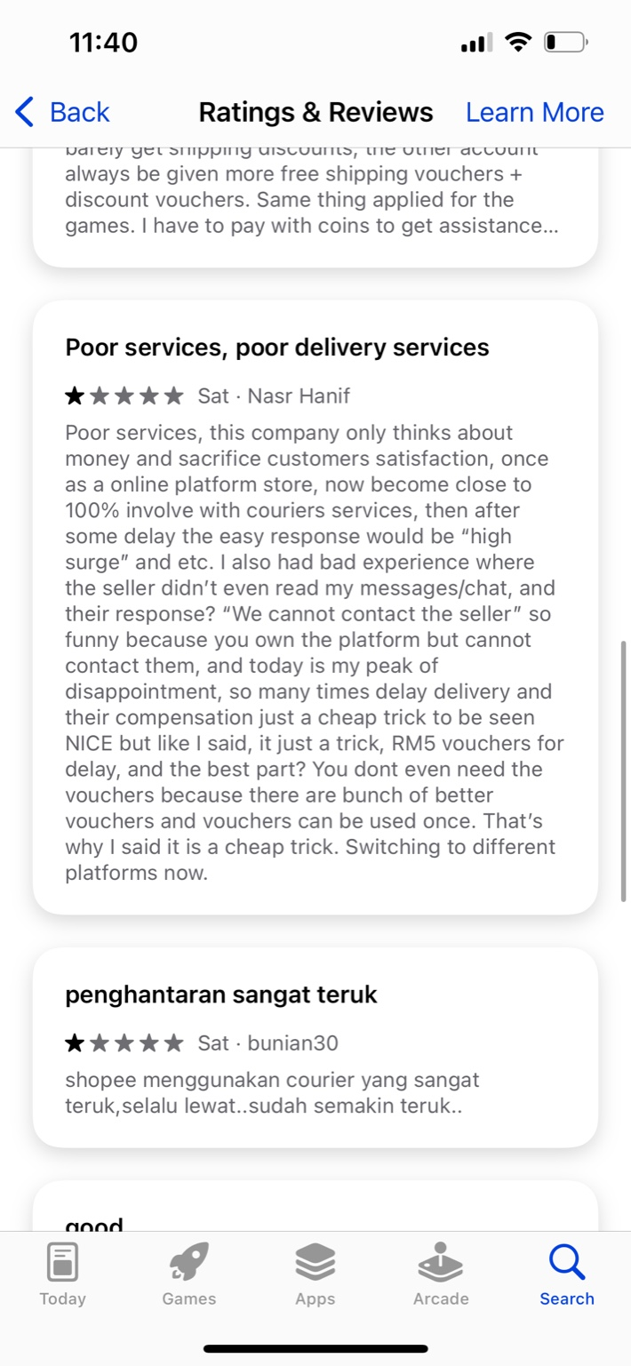

3b) A picture of proven of example,users feel disappointed about the vouchers.
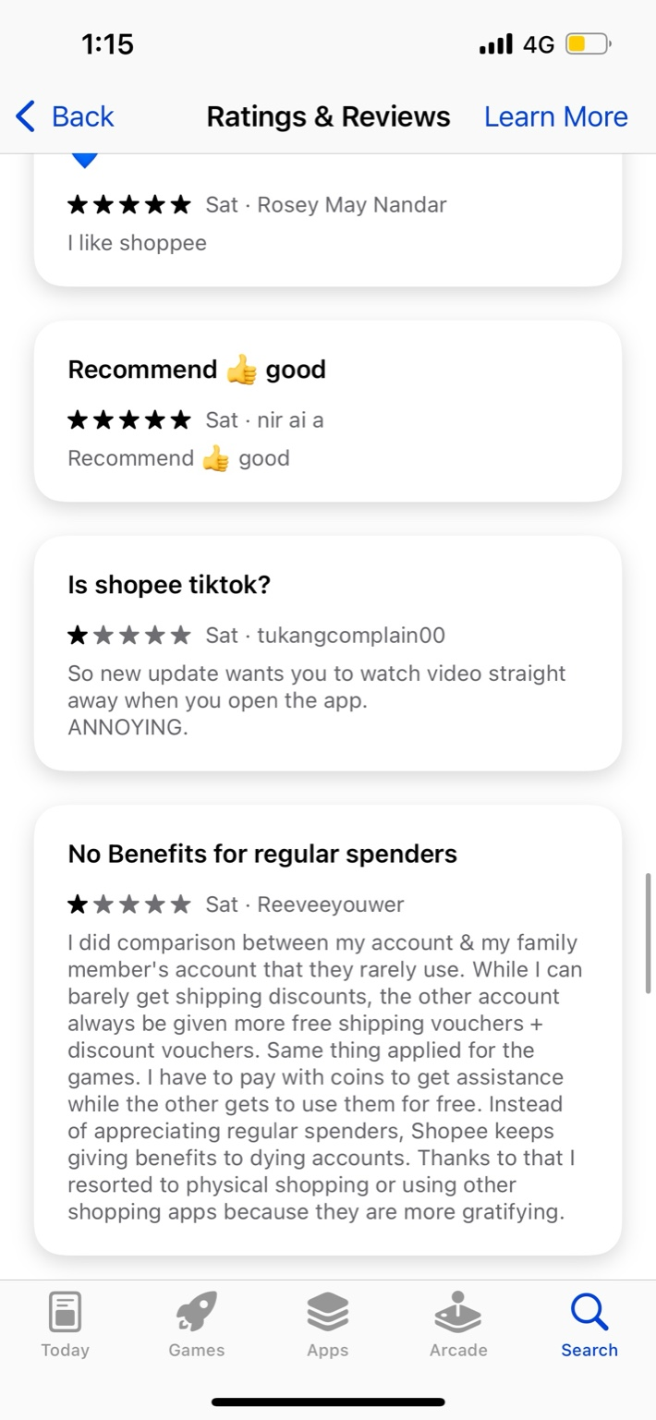

3d) Picture of example,users complain that the Shopee look like TikTok

3e) These 2 pictures show the homepage is clutter and too many ads
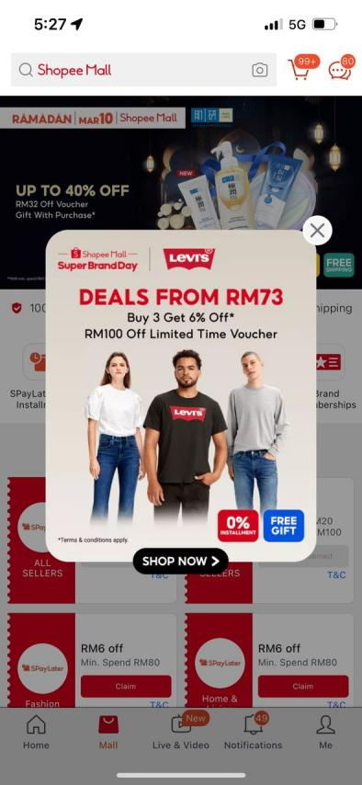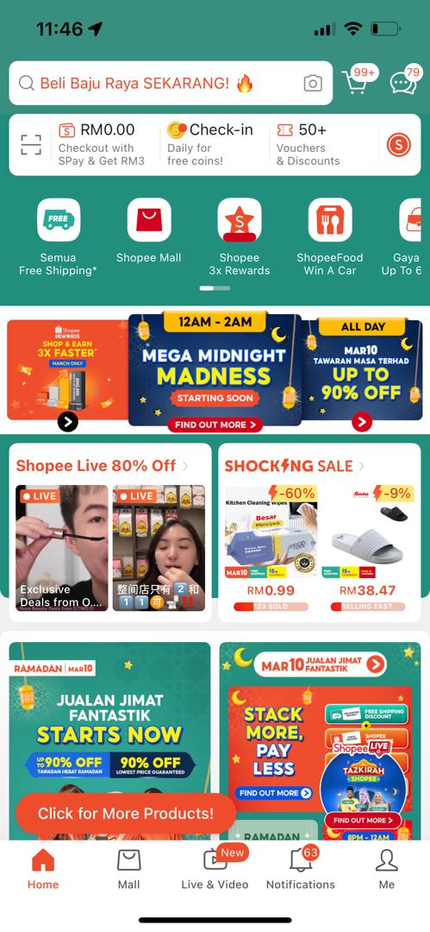

Heuristic Evaluation Checklist
Based on Jakob Nielsen’s 10 Usability Heuristics
Use this checklist to evaluate a user interface (UI) by identifying usability issues and suggesting improvements. Rate each heuristic on a scale of 1-5 (1 = Poor, 5 = Excellent) and provide comments for any issues found.
1. Visibility of System Status
- Does the system provide timely feedback for user actions?
- Are loading indicators, progress bars, or status messages displayed when needed?
- Do error messages appear when an action fails?
Rating (1-5): ___2.5____
Comments: __Order tracking together with notification updates and loading indicators represent some of the feedback options which Shopee provides to users. Several customers have noted that the platform delivers slow responses together with nontransparent delivery delay information. Customer reviews show that confusing or deceptive status messages communicated by Shopee trigger user frustration particularly when the order experiences delays. The status messages on Shopee should become clearer while the tracking updates need additional detail.The system should provide trackable order progress through precise updates and accurate time estimates.
2. Match Between System and the Real World
- Does the system use familiar icons, terms, and metaphors?
- Are labels and messages written in user-friendly language?
- Is the navigation intuitive and easy to understand?
Rating (1-5): ____3___
Comments: Shopee adopted traditional e-commerce conventions before the redesign when its design presented straightforward categories of listings alongside simple checkout features.The updated interface serves a major disruption to user expectations because its presentation includes automatic video playback and promotional content from influencers rather than the traditional shopping structure.Users grow confused because they do not recognize whether Shopee functions as an e-commerce store or social media platform._The business must focus its e-commerce strategy on product listings instead of social media-like content.____________________________
3. User Control and Freedom
- Can users easily undo or redo actions?
- Are there “Cancel” buttons or exit options for important tasks?
- Is it easy to recover from accidental actions?
Rating (1-5): ____2.5___
Comments: __People who use Shopee face problems during order cancellation operations along with undoing actions and accidental buy situations. The slow response times from customer service create difficulties for users to make instant corrections when mistakes occur. After placing an order users do not have control over delivery selection options since there are no alternative shipping providers or faster delivery options.Users often become aggravated when they encounter delayed shipping due to a lack of delivery freedom._Due to declining customer confidence in Shopee’s delivery methods the company received negative feedback and faced a deteriorating public image._Shopee should place the ability to cancel orders where customers easily find it before their shipment initiates.__________________________

4. Consistency and Standards
- Do buttons, menus, and icons follow standard design patterns?
- Are similar actions labelled the same across the system?
- Does the UI align with platform conventions (e.g., iOS, Android, web)?
Rating (1-5): ____2.5___
Comments: ___The design elements on Shopee do not establish a consistent look throughout each part of the site. The new update integrated various user interface elements that look like social media apps while breaking away from standard e-commerce design principles. Customers anticipate shopping at the platform yet the contradictory navigation together with button formats and interface hierarchy creates an unclear interface experience._Shopee users primarily expect an e-commerce encounter instead of social media functionalities.Productive users experience frustration because they need to surpass promotional videos to interact with shopping products.Leads to a sense of disconnection from the platform’s original purpose.The platform must enforce uniform designs for all buttons and menus.___________________________
5. Error Prevention
- Are users warned before performing irreversible actions?
- Does the system prevent common mistakes (e.g., required fields, data validation)?
- Are default settings reasonable and safe?
Rating (1-5): ___3____
Comments: _Users must confirm their orders on Shopee to proceed with purchases as a security measure among other preventive features. The platform consistently gets complaints about unwanted payments along with delivery service faults and deceptive promotional voucher presentations.Warning statements must appear prior to users confirming actions that cannot be undone (Example: “Please confirm your decision by clicking to proceed.”).The system must have an improved procedure for processing refunds for both incorrect orders and delayed delivery times._________________________________
6. Recognition Rather Than Recall
- Are important options always visible instead of hidden in menus?
- Does the system provide auto-suggestions or tooltips?
- Are previous user inputs or history easily accessible?
Rating (1-5): _3______
Comments: The interface of Shopee functions through recognition abilities of users instead of memory-based functions. Some features are hidden in navigation menus which creates difficulty for users to reach these features.Customers should find essential features like order history and cart and vouchers listing through quick and accessible routes.The platform should uses tooltips to display instructions about advanced features usage to customers._____________________________
7. Flexibility and Efficiency of Use
- Are there shortcuts for advanced users while keeping it simple for beginners?
- Can users customize their experience (e.g., settings, preferences)?
- Does the UI allow efficient task completion with minimal effort?
Rating (1-5): ___3____
Comments: Although Shopee serves novice and experienced shoppers it does not offer adaptable functions to boost operational effectiveness. The platform offers insufficient fast access solutions to users who often purchase items from the website._Customers should be able to modify their homepage layout according to how they prefer shopping at the site.The user compared their account to a family member’s and discovered that inactive accounts obtain superior benefits including free shipping vouchers and discounts.Those who frequently spend money with Amazon receive less reward compared to the actual revenue they provide.All non-essentials should be removed from the application which does not enhance shopping experience._________________________________
8. Aesthetic and Minimalist Design
- Is the interface clean and uncluttered?
- Does the UI avoid unnecessary elements that could distract the user?
- Is the colour scheme, typography, and layout visually appealing?
Rating (1-5): ___2.5____
Comments: ___The introduction of social media features combined with excessive promotion pop-ups as well as numerous notifications has created a disorganized user interface in the new Shopee platform. Core e-commerce operations become difficult to use because the interface creates confusion.Pop-up promotions should be decreased along with the amount of aggressive product advertisements.Shopee should redesign the user interface by adopting patterns which involve a minimalistic interface design along with abundant white spacing._______________________________

9. Help Users Recognize, Diagnose, and Recover from Errors
- Are error messages clear and helpful?
- Does the system provide solutions for fixing mistakes?
- Are error messages free of technical jargon?
Rating (1-5): __3_____
Comments: __A common problem among users involves their dissatisfaction with inadequate customer service together with problematic issue resolution. Error notices from Shopee often lack helpfulness while failing to provide usable instructions for users attempting to resolve their faults.The system provides specific detailed error messages when users encounter various issues like (“This item is out of stock” to assist with resolution. Try selecting a different size.”)._______________________________
10. Help and Documentation
- Is there an easily accessible Help section or FAQ?
- Are instructions available for complex tasks?
- Are there tooltips, tutorials, or onboarding guides for new users?
Rating (1-5): __3.5_____
Comments: ___Users can consult the Help section on Shopee but find it hard to navigate easily. Several users experience trouble when looking for matching support guides and when needing to reach customer service teams.Users should have full access to search capabilities throughout the help section.______________________________

